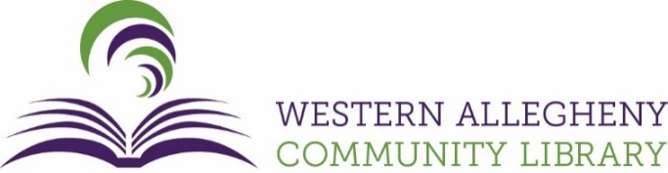
Youth Services Manager Job Posting
Position Summary
The Western Allegheny Community Library is seeking a visionary and dynamic Youth Services Manager to lead our vibrant Youth Services Department. This position oversees services and programming for children and teens from birth to age 18 and is responsible for the strategic development of youth collections, programming, outreach, and partnerships that reflect the library’s mission to serve and inspire lifelong learners.

The ideal candidate is creative, collaborative, and community-focused, with a passion for literacy, inclusivity, and youth engagement in a modern library setting.

Status: Full-Time Exempt (38 hours/week) | Schedule: Includes some evenings, weekends, and special events.
Compensation: Starting at $24.00 per hour, depending on experience. This full-time position includes a comprehensive benefits package with health, dental, and vision insurance, paid vacation, sick leave, and paid holidays.

Key Responsibilities
- Lead the planning, development, and implementation of innovative, inclusive programs for children, teens, and their families — including Summer Reading and early literacy initiatives.
- Manage and mentor a dedicated youth services team, providing supervision, training, and leadership to ensure high-quality service delivery.
- Develop and maintain the youth services collection, including print and digital resources, aligned with current interests, trends, and educational standards.
- Collaborate with local schools, childcare centers, and community organizations to enhance library visibility, expand outreach, and support literacy and learning.
- Serve on the library leadership team, working cross-departmentally to support system-wide goals, strategic planning, and library-wide initiatives.
- Continuously evaluate services using data, community feedback, and professional best practices.
- Maintain current knowledge of youth literature, trends in youth librarianship, and evolving technology and educational tools.
- Ensure a welcoming, inclusive environment for all youth and families, aligned with the library's values of diversity, equity, and inclusion.

Qualifications
Required:
- Master’s Degree in Library and Information Science from an ALA-accredited institution (or equivalent experience/degree in education or youth-focused field)
- At least 2–5 years of experience in a public library youth services role, with proven success in program development, outreach, or collection management
- Experience supervising staff or leading teams
- Strong knowledge of children’s and young adult literature, early literacy frameworks, and reader’s advisory tools
- Excellent communication, collaboration, and problem-solving skills
- Flexibility and creativity in a fast-paced, community-centered environment
- PA State Police Criminal Record Check, PA Child Abuse History Clearance, and FBI Fingerprint Clearance (or ability to obtain upon hire)

Preferred:
- Experience with literacy assessment tools (e.g., AR, Lexile, F&P)
- Experience developing community partnerships and/or grant writing
- Comfort using technology and digital platforms to enhance programming and outreach

Why Work With Us?
Western Allegheny Community Library offers a collaborative, innovative, and family-friendly work environment that prioritizes a healthy work-life balance. We strive to provide the best possible experience for both our patrons and our team.

We value diversity in all its forms and are committed to fostering an inclusive workplace. All qualified applicants will be considered for employment without regard to race, color, religion, sex, gender identity or expression, sexual orientation, national origin, disability, age, veteran status, or genetic information.

Benefits Include:
- Paid vacation, sick leave, and holidays
- Health insurance options (for eligible employees)
- Professional development support
- A supportive, team-oriented culture focused on community impact

To Apply:
Please submit your resume and a cover letter detailing your qualifications and interest in the role to partykam@westernalleghenylibrary.org. Applications will be reviewed on a rolling basis until the position is filled.

